Venkateshwar Reddy. N
192312193
Slot A

Experiment: 7
Analog Beamforming Analysis Using MATLAB

Objective – 1
Analyze Beamforming Gain (dB)
Generate beamforming gain values for different antenna array sizes using MATLAB. Compare how increasing the number of antenna elements improves the beamforming gain and enhances signal strength.
MATLAB Code:
clc;
clear;
close all;
antennas = [2 4 8 16 32];
gain = 10*log10(antennas);
figure
bar(antennas, gain)
grid on
xlabel('Number of Antenna Elements')
ylabel('Beamforming Gain (dB)')
title('Beamforming Gain for Different Antenna Array Sizes')

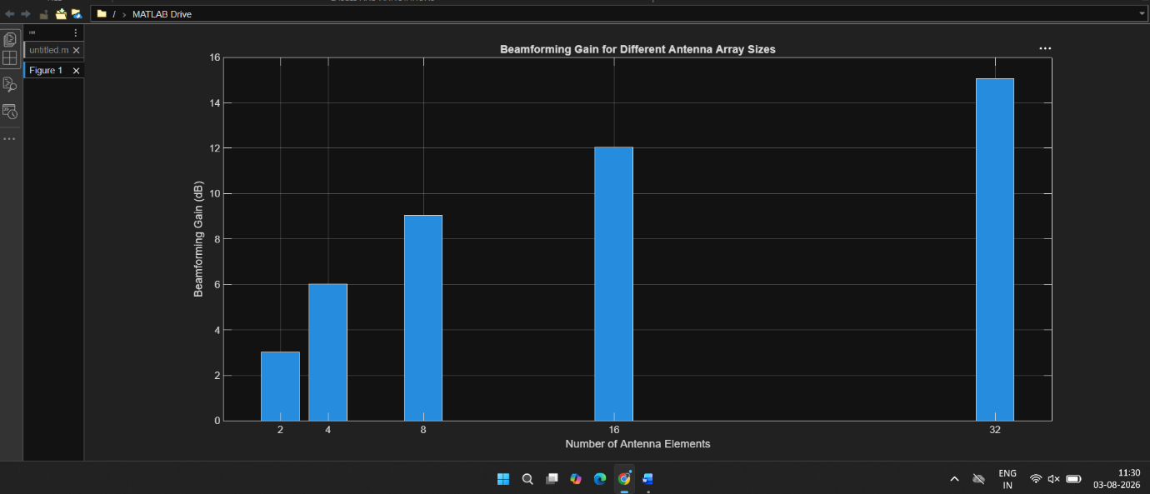

Objective – 2
Compare Beam Width (Degrees)
Analyze the beam width corresponding to different antenna array sizes using MATLAB. Observe how increasing the number of antenna elements results in a narrower beam, thereby improving spatial resolution.
MATLAB Code:
clc;
clear;
close all;
antennas = [2 4 8 16 32];
beamwidth = [90 45 22.5 11.25 5.625];
figure
plot(antennas, beamwidth,'o-','LineWidth',2)
grid on
xlabel('Number of Antenna Elements')
ylabel('Beam Width (Degrees)')
title('Beam Width for Different Antenna Array Sizes')

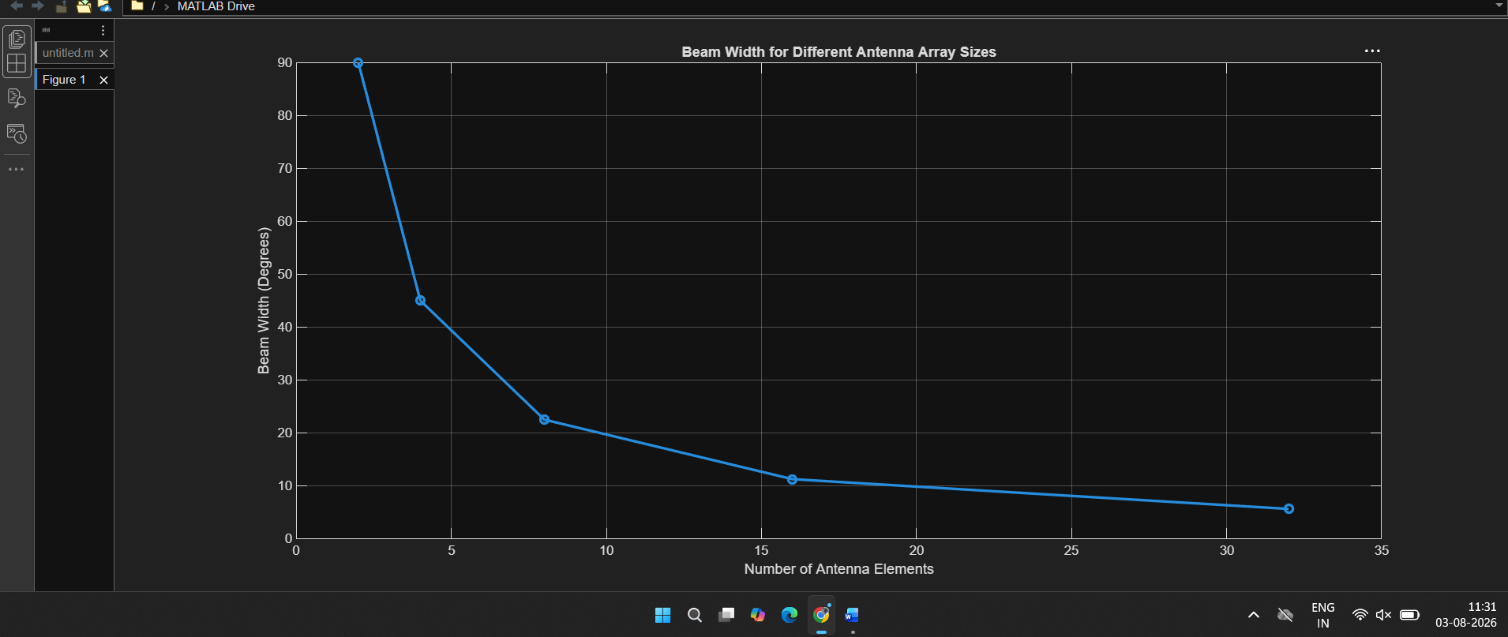

Objective – 3
Analyze Main Lobe Direction (Degrees)
Simulate beam steering by varying the steering angle of the antenna array using MATLAB. Observe the change in the main lobe direction and understand how analog beamforming directs energy toward the intended user.
MATLAB Code:
clc;
clear;
close all;
theta = [-60 -30 0 30 60];
gain = [1 1 1 1 1];
figure
polarplot(deg2rad(theta), gain, 'o', 'LineWidth', 2)
title('Main Lobe Direction in Analog Beamforming')
